HIGH SCHOOL COUNSELORS ASSOCIATION OF WNY COLLEGE TOUR 2019

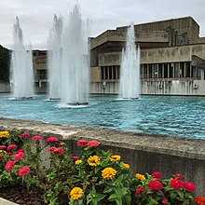

Please come and join us on a college tour!!
We will be visiting Ithaca College!
Date: May 20th, 2019
Time: 6:30am-5:00pm
Please RSVP to Dave Benton by phone or email by May 10th if you plan on attending
Phone: 362-8169
Email: dbenton@amherstschools.org
Agenda:
6:30am – Leave Buffalo

9:30am – Arrive at Ithaca College

9:45am - Admissions Presentation

10:15am – Campus Tour

11:45am – Lunch in Ithaca Food Court

12:30pm – Depart for Home

